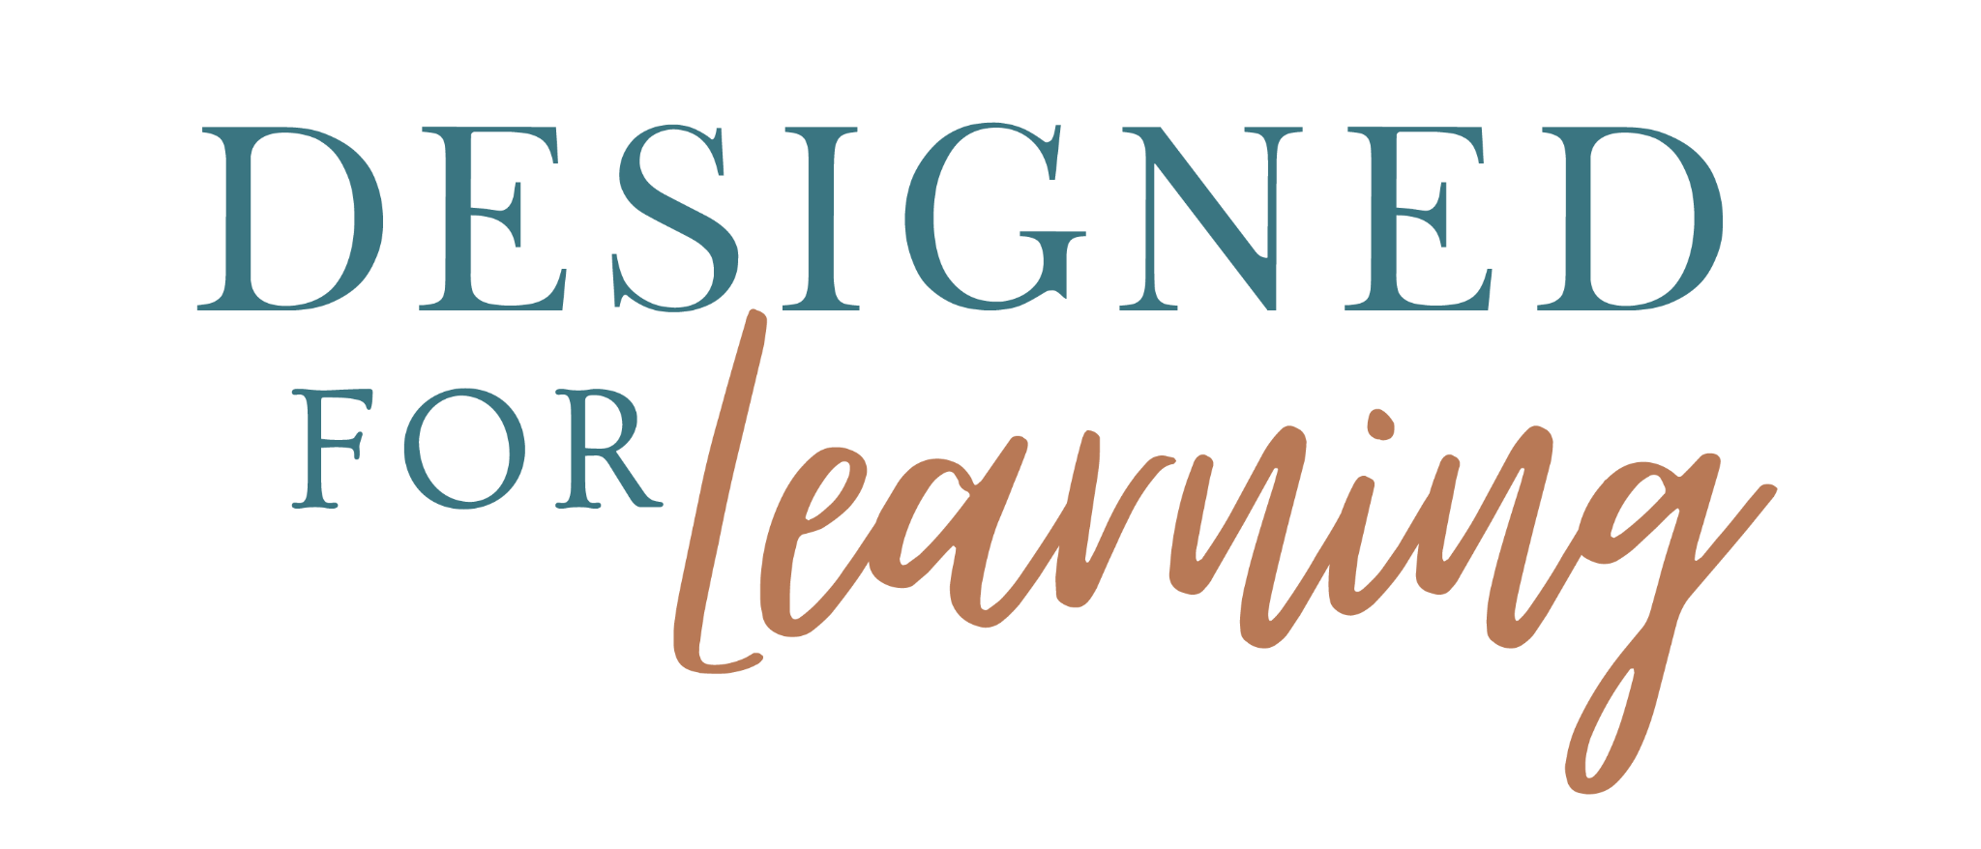 | 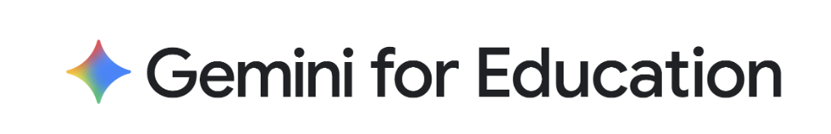

Caltech
November 17 – 20 - Gemini Sessions
A 90-minute interactive showcase for Caltech faculty, researchers and staff, offered four times. Choose the day that works for you: each session covers the same content.
Gemini’s data protections and FERPA alignment, prompting frameworks, Gemini in Gmail, Docs, Sheets and Drive, Gemini Gems, Gemini Notebook for cited research summaries, and vibe coding with Gemini Canvas. You’ll leave with ready-to-use prompts and a path to keep growing through the Google AI Educator Series.
Schedule
Session  01 | Smarter Research, Streamlined Workflows: Elevating Faculty, Research, and Staff Productivity with Gemini  Join the Workshop Here ·  Add to Outlook Calendar - Add to Google Calendar | Tuesday, Nov 17  10:00 – 11:30 AM  Pacific Time

Session  02 | Smarter Research, Streamlined Workflows: Elevating Faculty, Research, and Staff Productivity with Gemini  Join the Workshop Here ·  Add to Outlook Calendar - Add to Google Calendar | Wednesday, Nov 18  10:00 – 11:30 AM  Pacific Time

Session  03 | Smarter Research, Streamlined Workflows: Elevating Faculty, Research, and Staff Productivity with Gemini  Join the Workshop Here ·  Add to Outlook Calendar -Add to Google Calendar | Thursday, Nov 19  10:00 – 11:30 AM  Pacific Time

Session  04 | Smarter Research, Streamlined Workflows: Elevating Faculty, Research, and Staff Productivity with Gemini  Join the Workshop Here ·  Add to Outlook Calendar -Add to Google Calendar | Friday, Nov 20  10:00 – 11:30 AM  Pacific Time

Location  Virtual · YouTube live stream  Use the “Watch live on YouTube” link for your session day.  Please complete the session evaluation at the end of your session. | Contacts  Ash Hadi · Caltech  Ed Dougherty · Presenter, Designed for Learning  Katie Ecklund · Moderator, Designed for Learning  Molly Bennett · Designed for Learning · molly@dforlearning.com

